Asia-China-Coin-Spade-Square Foot-H 3.470 R5

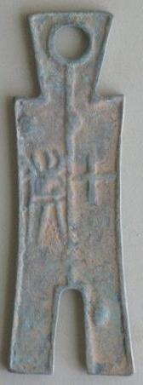 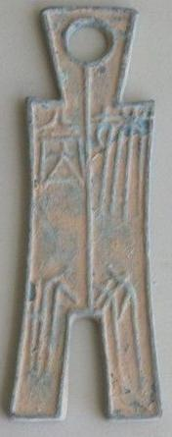

9cm X3cm, 3.54 inch X1.18inch

The weight：40g